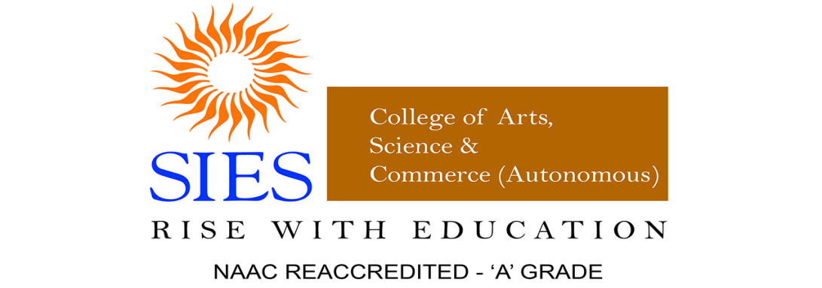

Report
- Title of the Workshop: RAMAN EFFECT AND ITS APPLICATION & DEMONSTRATION OF INSTRUMENTS (POTENTIOSTAT & PORTABLE FLUORIMETER’
- Background: During the academic year 2022 – 2023 for the Celebration of National science day, Guest Lecture organized by Science Association in collaboration with Department of Chemistry had organized Guest lecture on Raman effect and its application and demonstration of instruments (potentiostat & portable fluorimeter) by Dr. Asim Kumar Maiti Proprietor of Advantek Instrument, Seawoods, Navi Mumbai to explore spectroscopic knowledge on the occasion of National Science day ( 28th February 2023) for under graduate and post graduate students.
- Aims/Objectives:
- To explain why we celebrate national science day.
- To understand the application of Raman Effect.
- To broaden students' minds in the field of research.

- Location: Room no 08 first floor and Jr. Chemistry Laboratory SIES College of arts, science, and Commerce (autonomous) Sion (w) Mumbai
- Target audience/participants with expected number: UG and PG Students (120)
- Session and name of Resource Persons:
Dr. Asim Kumar Maiti
Ph.D. from Indian Association for the Cultivation of Science, Kolkata Postdoc:
1) University of Mainz, Germany,
DAAD Fellowship
2) University of Valencia, Spain 3) University of Windsor, Canada Field of Research:
Raman Spectroscopy, Fluorescence, IR Spectroscopy
- Schedule:
The program was conducted in S.I.E.S College, Mumbai room no. 8.
It was followed by a question-answer session between the resource person and participants. -Dr. Asim Kumar Maiti discussed why we celebrate national science day. He narrated the inspiring life story of C.V. Raman. He also showed some applications of the Raman Effect in the pharmaceutical field and other fields.
Dr. A.K. Maiti and Mrs Maiti showed students the instrumentation of Potentiostat & Portable Fluorimeter.

Outcome: The feedback of participants reflects the following points:
1. Attend more lectures like this in future
2. Helped opening new ideas and thoughts in the research field.
3. Got to know many applications of Raman Effect.
Funding if any: (NIL)
- Annexures:
- List of Participants (attached)

- Photographs (Geotagged)

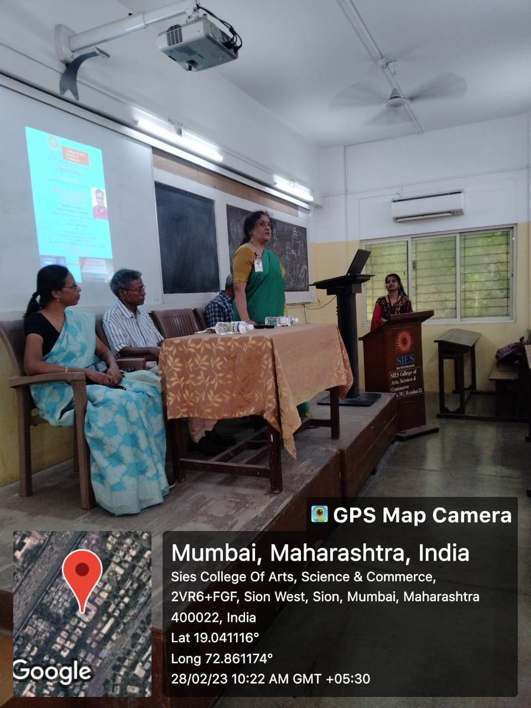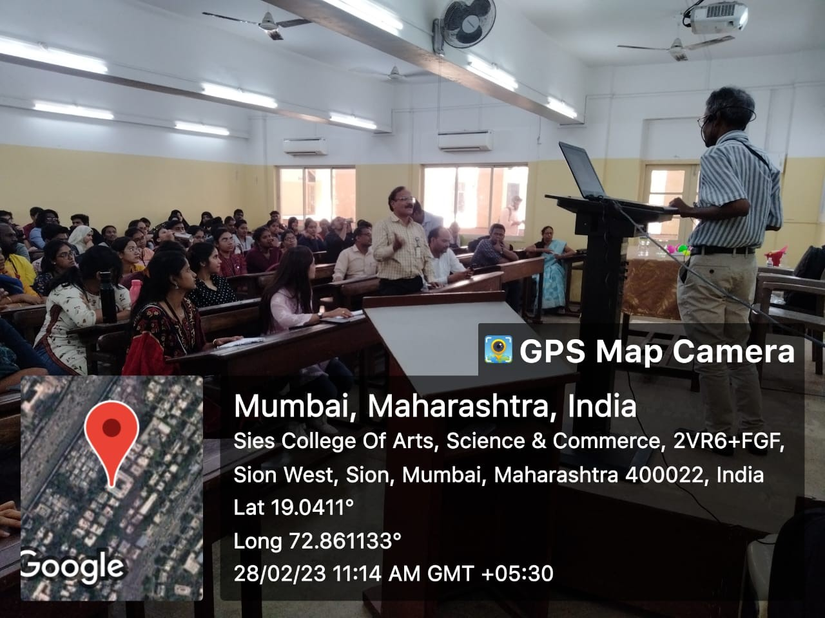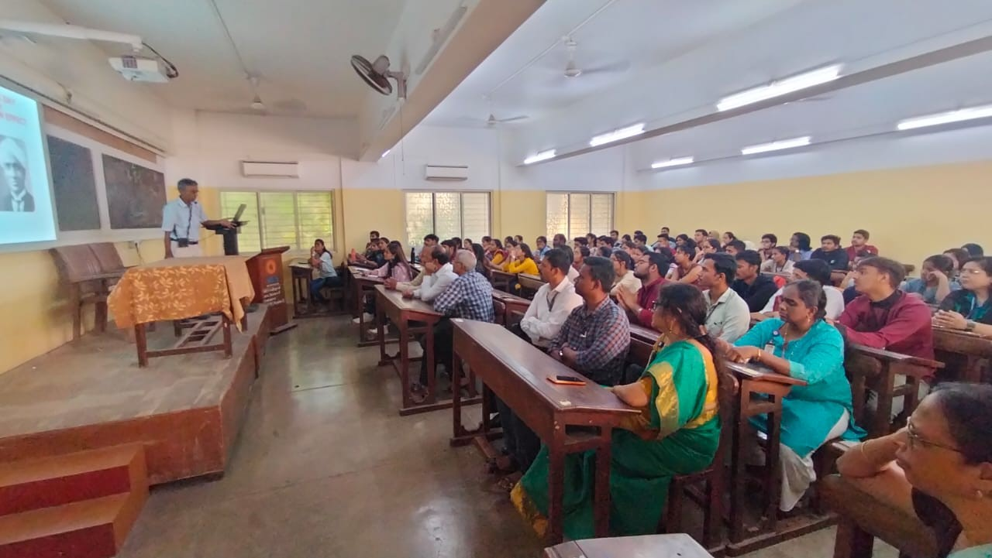
Annexure
2:
Flyer
Annexure
3:
Attendance
of
the
Guest
Lecture

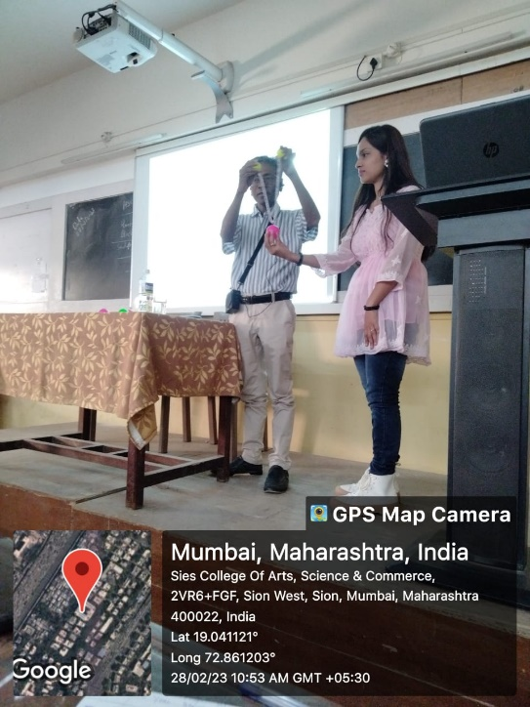
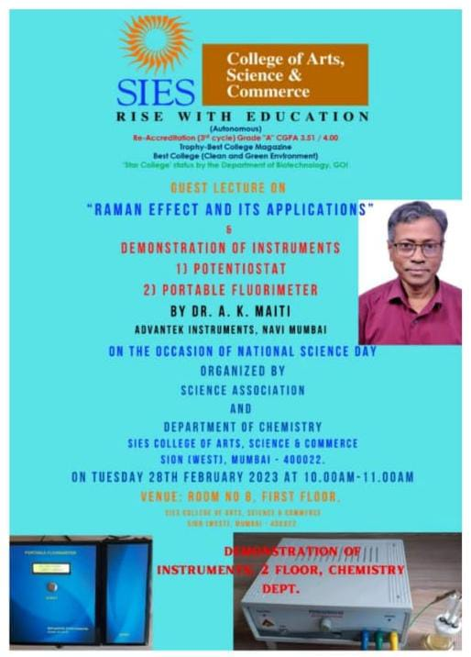

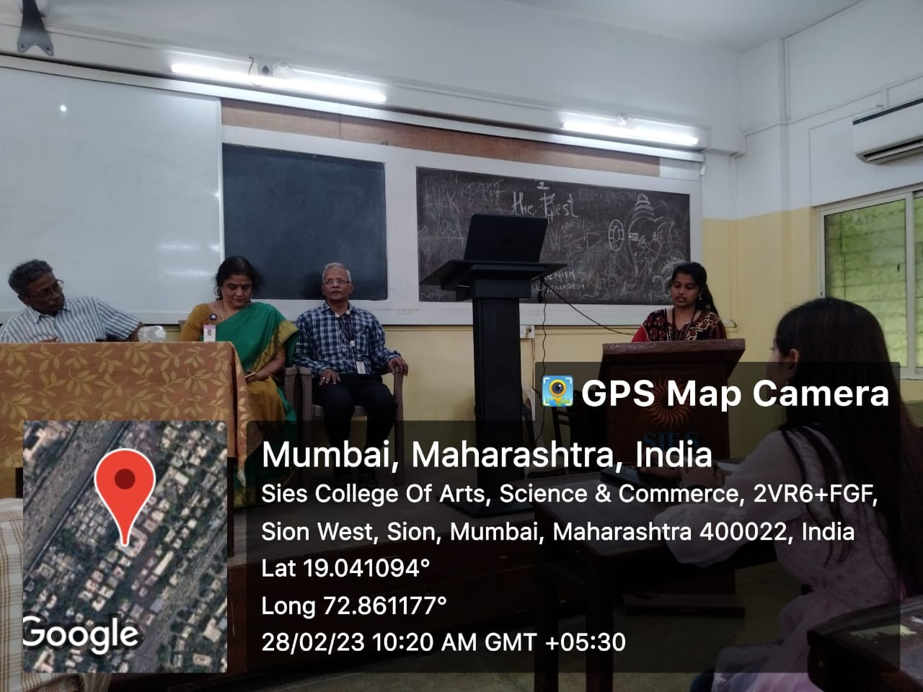
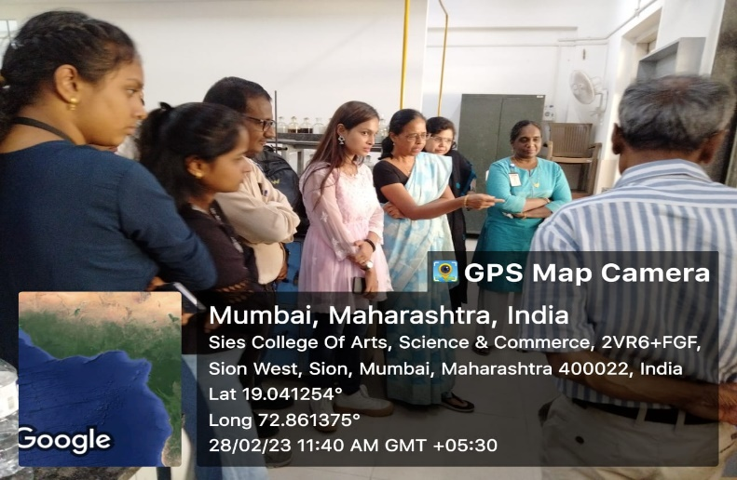

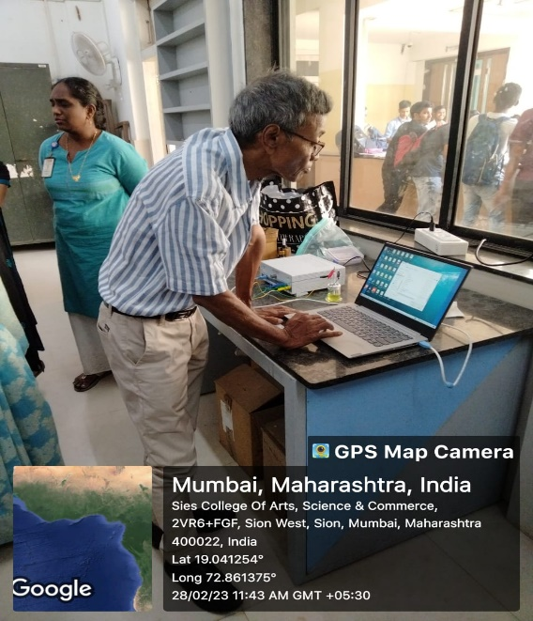
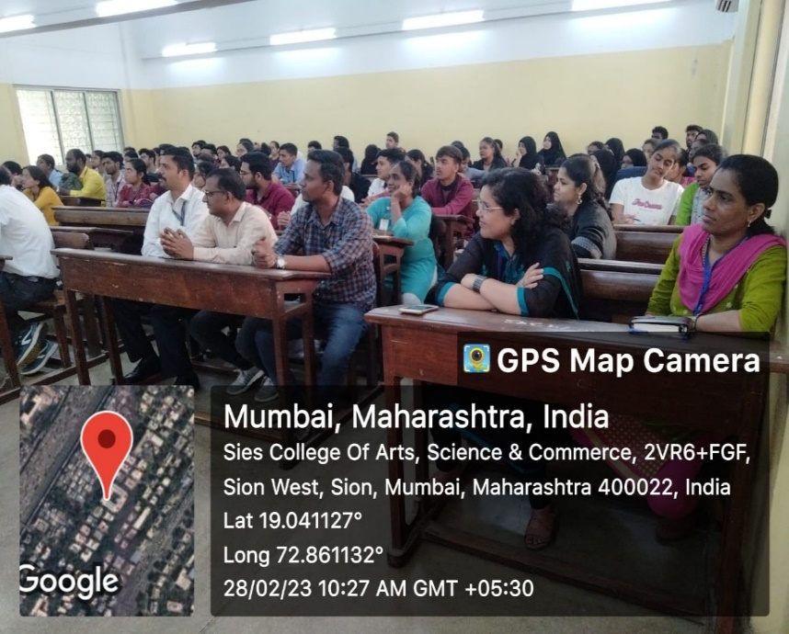

Report Prepared by
Signature: Signature of HOD
Name: Dr. Nitin Mirgane
Department: Chemistry
Designation: Assistant Professor

